NAME:VENKATRAMAMOORTHY.G
- Rewrite code with let and const.
CODE:
const name="venkat";
console.log("the name is constent"+' '+name);
let age = 21;
console.log("the age is let"+' '+age);
age = 22;
console.log("after update the age"+' '+age);
OUTPUT:
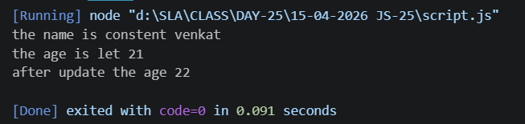
- Use template literals with variables.
CODE:
const name="venkat";
console.log("the name is constent"+' '+name);
let age = 21;
console.log("the age is let"+' '+age);
age = 22;
console.log("after update the age"+' '+age);
console.log(`My name "${name}" my age is "${age}"`);
OUTPUT:
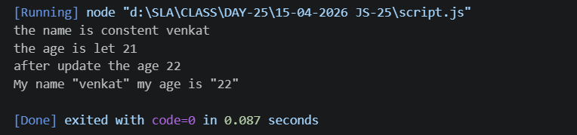
- Create a function with default parameter values.
CODE:
function display(name="guest"){
console.log(`function with defaut paramater ${name}`);
}
display();
display("venkat");
OUTPUT:
